ALCOHOLS, PHENOLS AND ETHERS || 163163

UNIT-10

ALCOHOLS, PHENOLS AND ETHERS
Quick Concepts to Remember

- Hydroxyl (− OH) derivatives of alkane are called alcohols.
- Alcohols are classified as 1º, 2º and 3º.
- −OH group is attached to sp³ hybridized carbon. Alcohols further may be monohydric, dihydric and polyhydric on the basis of OH group.
- Phenols : Compounds containing – OH group bound directly to benzene ring.

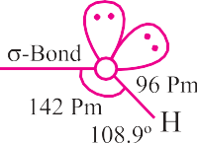
- 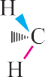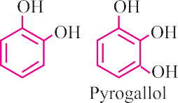Structure : Oxygen atom is sp³ hybridised and tetrahedral geometry of hybrid atomic orbitals ROH bond angle depends upon the R group. R – O – H angle for CH₃ – OH is 108.9º.
- Isomerism :
  - Functional isomerism
  - Chain isomerism
  - Positional isomerism
- General Methods of Preparation :
  - Acid catalysed hydration of alkenes :

  - 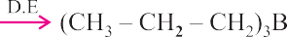Hydroboration oxidation :

  - 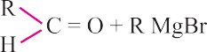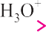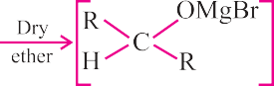From carbonyl compounds with Grignard’s reagent :

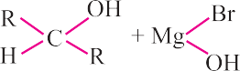

Formaldehyde gives 1º alcohol and ketones gives tertiary alcohol.
  - By reduction of carbonyl compounds :

RCHO + 2[H]
- P⎯d → RCH OH

H C = O + 2[H] NaBH4 H R R
2

CH2OH

R
C = O + 2[H]
R
NaBH4 R R

CHOH

  - By reduction of esters with LiAlH4 or Na/C2H5OH :
O
R–C– OR' + 4[H] LiAlH4 R– CH OH + R' – OH
2

  - By hydrolysis of esters :
O
conc
H2SO4

R – C – O – R' + H₂O

O
R – C – OH + R' – OH

  - From alkyl halides :
R – X + KOH (aq) → R – OH + KX
  - By reduction of acids and their derivatives :

R – COOH
- L⎯iAlH⎯4 → RCH OH

R – COCl + 2H ⎯N⎯i → R.CH OH + HCl
2
2 2
  - From 1º amines :

R – NH2
- ^{N}⎯^{aN}⎯^{O}2 ⎯^{+HC}⎯^{l}→ROH + H2O + N2

NAME REACTIONS
ALCOHOLS, PHENOLS AND ETHERS | 165
- Reimer Tiemann Reaction x
O Na
–
+
OH

O Na+

CHCl2

CHCl3 + aq NaOH
–
CHO
NaOH

Intermediate

H+

OH
CHO

Salicyaldehyde

Kolbe reaction
OH

NaOH

ONa

- CO2
- H+

OH
COOH

- Hydroxybenzoic acid (Salicylic acid)

Friedel craft reaction
OCH3

+ CH3CI

Anhyd. AlCl 3
CS2

OCH3

CH3
+

OCH3

OCH3

+ CH3COCl

Ethanoyl chloride

Anhyd. AlCl3
2-Methoxy- toluen (Minor)

OCH3
COCH3
+

2-Methoxy- acetophenone
CH3
4-Methoxy toluen (Major)

OCH3

COCH3

4-Methoxy-
(Minor)
acetophenone (Maior)

- Williamson synthesis: Reaction with alkyl halide with sodium alkoxide or sod. Phenoxide is called Williamson synthesis.
166 | Chemistry-XII
R–X + R1 – O– Na R – O – R1 + NaX
CH3I + CH3CH2ONa CH3O.CH2 – CH3 + Nal
ONa

CH3CH2 –I + + Nal

Both simple and mixed ether can be produced.
Depending upon structure and cleavage of unsymmetrical ethers by halogen acid may occur either by SN² or SN¹ mechanism.

MECHANISMS
- Hydration of Alkene :

C = C + H2O
H' C— C

H OH

CH3CH = CH2 + H2O

Mechanism
H'
CH3 – CH – CH3

OH

The mechanism of the reaction involves the following three steps:
Step 1: Protonation of alkene to form carbocation by electrophilic attack of H O⁺.
3
H O + H+ H O+
2
3

H H +
: :

C = C + H – O+ – H
C C + H2O

Step 2: Nucleophilic attack of water on carbocation.

H

C C+ + H O
:
:
2
H H
C C O+ – H

Step 3: Deprotonation to form an alcohol.
:
3

H H
C C O+ – H + H O:
:
2
H :OH
C C
:

+ H O+

Dehydration Reaction
ALCOHOLS, PHENOLS AND ETHERS | 167

100°C/373 K

CH3 – CH2HSO4

CH3 – CH2 – OH

- 2CH3CH2OH

Mechanism:
H2SO4
Conc.

Conc.
H2SO4 413 k

413 K

433 TO 444 K

CH3CH2OCH2CH3

H

CH3CH2 – OCH2 – CH3 CH2 = CH2 + H2O

Step 1: CH CH OH + H+ CH CH O H
: :
3 2
3 2
+

+ .. +

Step 2: CH3CH2 —O—H + CH3CH2O. .H
|
H
CH3CH2 —O— CH2CH3+H2O
|
H

+
Step 3: CH3CH2 —O— CH2CH3
|
H

CH CH OCH CH + H+

- CH₃CH₂OH ⎯^{C}⎯^{on}⎯^{c.} ^{H}⎯2SO⎯4 →H₂C = CH₂ + H₂O
3 2 2 3
443 K

Step 1:

..
CH3CH2 O. .H + H+

Fast
H
| CH3CH2 O. .—H
+

+
Step 2: CH3CH2 —O—H
|
H

Slow

+
CH3CH2 +H2O

H H
| |
Step 3: H —C—C—H CH = CH + H+
2 2
| +
H

IMPORTANT PREPARATIONS
168 | Chemistry-XII
- Preparation of phenol from Cumene
CH3 CH3

CH3 CH

CH3

O3
C–O–O–H

H+ H2O
OH

+ CH3COCH3

Cumene Cumene
Hydroperoxide

Prepation os spirin
COOH COOH
OH OCOCH3
H+
+ (CH3CO)2O

+ CH3COOH

Salicylic acid
Acetylsalicylic acid (Aspirin)

- Ethers are dialkyl derivatives of water or monoalkyl derivatives of alcohols with formula R – O – R'
- Lucas test can be used to distinguish primary, secondary and tertiary alcohols (ZnCl₂ + HCl).
(3º turbidity – instant, 2º - 5 minutes, 1º - heating for 60 minutes)
- Ethers are relatively inert and hence are used as solvents.
- 100% ethanol is known as absolute alcohol.
- 95% ethanol is called rectified spirit.
- A mixture of 20% ethanol and 80% gasoline is known as power alcohol.
- Iodoform test is used for distinguishing compounds having the groups

- Presence of EWGs increase the acid strength of phenols while EDG decrease the acid strength.
EWG : − NO₂, − X, − CN, − COOH etc.
EDG : − R, − OR, − OH, − NH₂ etc.
- 3º alcohols are resistant to oxidation due to lack of α-hydrogen.
- Intermolecular H-bonds of p- and m-nitrophenol increases water solubility/acid strength while intramolecular H-bonds in o-nitrophenol decreases these properties.
- In the reaction of alkyl aryl ether (anisole) with HI, the products are always alkyl halide and phenol because O – R bond is weak than O – Ar bond which has partial double character due to resonance.

- C – O – C bond in ether is bent and hence the ether is always polar molecule even if both alkyl groups are identical.
ALCOHOLS, PHENOLS AND ETHERS | 169

MULTIPLE CHOICE QUESTIONS

Arrange the following compound in decreasing order of boiling point
  - propan-1-ol (ii) butane-1-ol
(iii) butan-2-ol (iv) pentan-1-ol
(a) i > iii > ii > iv (b) i > ii > iii > iv
(c) iv > iii > ii > i (d) iv > ii > iii > i

What is the correct order of reactivity of alcohols in the following reaction?

R—OH + CHl
- Z⎯n,d⎯ust⎯→ R—Cl + H O

(a) 1° > 2° > 3° (b) 1° < 2° > 3°
2
(c) 3° > 2° > 1° (d) 3° > 1° > 2°
CH3
- IUPAC name of the compound C3H—CH—O—CH3 is:
(a) 1-methoxy-1-methyl ethane (b) 2-methoxy-2-methyl ethane
(c) 2-methoxy propane (d) isopropylmethyl ether

The correct order of decreasing acid strength of the following compound is:

OH

(i)

(ii)
OH
NO2
(ii)
OH
OCH3

(a) i > ii > iii (b) iii > ii > i
(c) ii > i > iii (d) ii > iii > i

In the reaction :
C3H—CH—CH2—O—CH2—CH3 + HI CH3

heat

CH3
- CH₃—CH—CH₂—OH + CH₃—CH₃
- CH3—CH—CH3—CH3 + CH3CH2—OH
CH3 CH3
- CH3—CH—CH2—OH + CH3—CH2—I
- CH3—CH—CH2—I + CH3CH2—OH CH3

Phenol Z is
X
⎯⎯⎯^{CH}⎯3Cl ⎯⎯→
anhydrous AlCl₃
170 | Chemistry-XII
  - a⎯lkal⎯ine ⎯KM⎯nO4⎯→ Y ⎯a⎯lkal⎯ine ⎯KM⎯nO4⎯→ Z, The product

(a) Benzaldehyde (b) Benzoicacid
(c) Benzene (d) Toluene

Which is most acidic
OH

OH CH
(a) (b)

(c)
CH2—OH
OH

(d)

The electrophile involved in the given reaction is:

OH

+ CH₃Cl + NaOH
ONa⁺

CHO

(a) :CCl (b) –CCl
2 3
(c) ⁺CHO (d) ⁺CHCl
2

The major product obtained on interactionof phenol with NaOH and CO₂ is
(a) Benzoic acid (b) Salicaldehyde
(c) Salicylic acid (d) Pthalic acid

In the following sequence of reaction
CH —CH —OH ⎯^{P}⎯^{I}v⎯→ A ⎯⎯^{Mg}⎯→ B ⎯^{H}⎯^{CH}⎯^{O}→C ⎯^{H}⎯2O⎯→ D
3 2 ether
The product D is:
- n-butylalcohol (b) n-propylalcohol
(c) propanal (d) butanal
ONa

    - CO
⎯¹⎯^{25°}⎯^{C}→ B ⎯⎯^{H}+⎯→ C
2
2 5 atm AC O

(a)
OCOCH3
(b)
COOH
OCOCH3

OCOCH3
COOH

OH

(c)
COCH3 COCH3
(d)
COOCH3

12. + CH3—CH—CH3 COCH3
⎯A⎯lCl⎯3 →
  - 3 130°C
  - ⎯^{H}⎯+ → Phenol + C

Identify ‘C’ in the following is:
    - Water (b) Ethanol
(c) Cumenehydroperoxide (d) acetone

Iodoform canbe prepared from all except
  - butan-2-one (b) acetophenone
(c) propan-2-ol (d) propan-1-ol

The ether O CH₂ when treated with HI produces
  - CH2 I (b) CH2 OH
(c) I (d) CHO
- O CH3 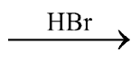 the products are:

  - Br
OCH3 + H2
  - Br + CHBr3

  - Br + CH2Br4 (d) d
ALCOHOLS, PHENOLS AND ETHERS | 171

Which of the following alcohol on dehydration with conc H₂SO₄ gives but-2- enc?
  - 2-methylpropan-2-ol (b) Butan-1-ol
(c) 2-methyl propan-1-ol (d) Butan-2-ol

Which of the following alcohol give iodoferm test?
  - Butan-1-ol (b) Propan-1-ol
(c) Propan-2-ol (d) Ethanol

Which of the following is a weaker acid than phenol?
  - 4-Methoxy phenol (b) 3, 5-dinitrophenol
(c) 4-Methyl phenol (d) 4-Nitrophenol

The ether O—CH2 when treated with HI produces.
  - CH₂ I (b) CH2 OH
(c) I (d) OH

Correct statements in case of n-butanol and t-butanol are:
  - both are having equal solubility in water
  - t-butanol is more soluble in water than n-butanol
  - boiling point of t-butanol is lower than n-butanol
  - boiling point of n-butanol is lower than t-butanol

Assertion Reason Type Questions
172 | Chemistry-XII
The question given below consist of an Assertionand the Reason. Use the following key to choose the appropriate answer.
- If both assertion and reasonare CORRECT and reason is the CORRECT explanation of the assertion.
- If both assertion and reason are CORRECT, but reason is NOT the CORRECT explanation of the assertion.
- If assertion is CORRECT but reason is INCORRECT.
- If assertion is INCORRECT but reason is CORRECT.
- If both assertion and reason are INCORRECT.
- Assertion: The boiling point of alcohol is higher than those of hydrocarbons of comparable moleculal mass.
Reason: Alcohol show intramolecular hydrogen banding.
- Assertion: O and p-nitrophenols can be separated by steam distillation.
Reason: O-isomeris steamvolatile due to chelation and p-isomer is not steam volatile due to intermolecular hydrogen bonding.

Matching Column Type
- Match the column
- Methanol and ethanol P. lucas reagent
- Phenol and cyclohexanol Q. Sodium metal
- n-propylalcohol and tertbutyl alcohol R. Iodoformtest
- Methanol and diethylether S. Ferric chloride
  - A–Q, B–S, C–P, D–R (b) A–S, B–P, C–Q, D–R
(c) A–P, B–Q, C–R, D–S (d) A–R, B–S, C–P, D–Q

Match the column
- Willionsan synthesis P. Conversion of phenol to salicylic acid
- Conversion of 2° alcohol to ketone Q. Conversion of phenol to
salicaldehyde
- Reimer Tiemann reaction R. Heated with Cu-573k.
- Kolbc's reaction S. reaction of alkyl halide with sodium alkoxide
  - A–S, B–R, C–Q, D–P
  - A–R, B–S, C–Q, D–P
  - A–R, B–Q, C–P, D–S
  - A–Q, B–P, C–R, D–S

Integer Type Questions
ALCOHOLS, PHENOLS AND ETHERS | 173
The answer to each of the following question is a single-digit integer ranging from 0 to
9. Darken the correct digit.

25. The number of alcohols giving iodoform test among the following is:
CH3CH2OH, CH3OH, CH3CH2CH2OH, (CH3)2 CHOH, CH3CH2CH2CH2OH, CH3CH2CH(OH)CH3, CH3CH(OH)CH(CH3)2, (C2H5)2CHOH, (CH3)3COH

0 | 1 | 2 | 3 | 4 | 5 | 6 | 7 | 8 | 9
ANSWERS
1. (d) 2. (c) 3. (c) 4. (c) 5. (c) 6. (b) 7. (d) 8. (a) 9. (c) 10. (b)
11. (b) 12. (d) 13. (d) 14. (a) 15. (d)
16. (b, d) 17. (c, d) 18. (a, c) 19. (a, d) 20.(b, c)
21. (c) 22. (a) 23. (d) 24. (a) 25. 4

VERY SHORT ANSWER TYPE QUESTIONS (1 Mark)

Q. 1. Write IUPAC name of the following compound :
Ans. 2,5-Dimethylhexane-1, 3 diol.

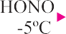Q. 2. How is phenol obtained from aniline ?
0

Ans.

Q. 3. Why phenol is acidic in nature ?
Ans. Due to stability of phenoxide ion by resonance.

Q. 4. Arrange the following in decreasing order of their acidic character :

(i)

Ans. (iii) > (ii) > (i)

(ii) C₆H₅OH (iii)

Q. 5. Among HI, HBr and HCl, HI is most reactive towards alcohols. Why ? Ans. Due to lowest bond dissociation energy of HI.
Q. 6. Name a compound which is used as antiseptic as well as disinfectant. Ans. Solution of phenol : 0.2% antiseptic, 2% disinfectant.

Q. 7. What is nitrating mixture ?

Ans. Conc. (H2SO4 + HNO3)
174 | Chemistry-XII
Q. 8. Lower alcohols are soluble in water, higher alcohols are not. Why ? Ans. Due to formation of hydrogen bonds.

Q. 9. What happens when CH₃CH₂OH heated with red P and HI ?
Ans. C2H5OH + 2HI ⎯⎯⎯→ C H + I + H O
Red P
2 6 2 2

Q. 10. Complete the following reaction :
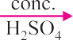

Ans.

2, 4, 6-Τrinitro phenol (Picric acid)

Q. 11. Ethanol has higher boiling point than methoxy methane. Give reason. Ans. Because of H-bonds.
Q. 12. How could you convert ethanol to ethene ?

Ans. C H OH
⎯C⎯onc⎯. H2S⎯O4⎯→ CH
= CH
+ H O

2 5 443 K 2 2 2

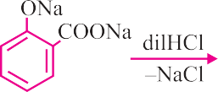Q. 13. Explain Kolbe’s reaction with example.
Ans.

Q. 14. Which of the following isomer is more volatile : o-nitrophenol or p-nitrophenol
Ans. o-nitrophenol.

SHORT ANSWER-I TYPE QUESTIONS (2 Marks)

Q. 1. Write one chemical reaction to illustrate the following :
- Reimer-Teimann reaction

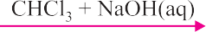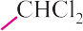Williamson’s synthesis

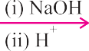
Ans. (i)

(ii)
ALCOHOLS, PHENOLS AND ETHERS | 175

Q. 2. Account for the following :
- Phenol has a smaller dipole moment than methanol.

Phenol goes electrophilic substitution reactions.
Ans. (i) Due to – ve charge on oxygen in delocalized by resonance.
(ii) Due to greater electron density than benzene.

Q. 3. Complete the following equations and name the products :
- Phenol + FeCl₃ →
- C H OH + CHCl + NaOH ⎯3⎯40 K⎯→
6 5 3
- 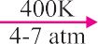C6H5OH + Br2 (aq) →

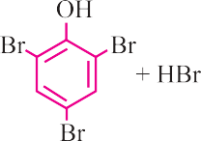
Ans. (i) [(C6H5O)3Fe] + 3HCl (ii) 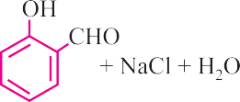
(iii) (iv)

Q. 4. Write :
- Friedel-Crafts reaction

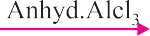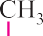Coupling reaction

Ans. (i)

(ii) C6H5N2Cl + C6H5OH ⎯p⎯H=⎯9-1⎯0→

Q. 5. Give one reaction of alcohol involving cleavage of :
- C – O bond

O – H bond
Ans. (i) CH3CH2OH + PCl5 → CH3CH2Cl + POCl3 + HCl
(ii) CH3CH2OH + Na → CH3CH2ONa + H2

Q. 6. Etherial solution of an organic compound ‘X’ when heated with Mg gave ‘Y’. ‘Y’ on treatment with CH₃CHO followed by acid hydrolysis gave 2-propanol. Identify the compound ‘X’. What is ‘Y’ known as ?
176 | Chemistry-XII
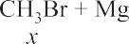
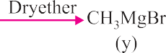
Ans.
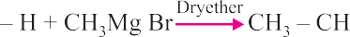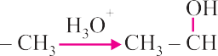

Q. 7. While separating a mixture of o- and p-nitrophenols by steam distillation name the isomer which is steam volatile. Give reason.

Ans.

H-bonding and association of molecules.

Q. 8. Account for the following :
- Phenol has a smaller dipole moment than CH₃OH.
- Phenol do not give protonation reactions readily. Ans. (i) Because phenol has electron attracting benzene ring.
(ii) Resonance and +ve charge oxygen does not have tendency to accept a proton.

Q. 9. Write the reactions and conditions involved in the conversion of :
- Propene to propan-2-ol.

Phenol to salicylic acid.

Ans. (i) CH3CH = CH2 + H2O

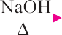(ii)
⎯H⎯2S⎯O4 (⎯dil.⎯)→ CH3 – CH – CH3
|
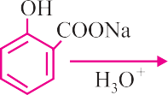
OH

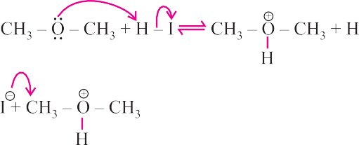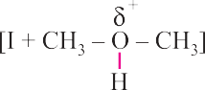Q. 10. Write mechanism of reaction of HI with methoxymethane. Ans.

Q. 11. Arrange in order of boiling points :
ALCOHOLS, PHENOLS AND ETHERS | 177
- C2H5 – O – C2H5, C4H9COOH, C4H9OH
- C3H7CHO, CH3COC2H5, C2H5COOCH3, (CH3CO)2O Ans. (i) C4H9COOH > C4H9OH > C2H5 – O – C2H5
(ii) (CH3CO)2O > C2H5COOCH3 > CH3COC2H5 > C3H7CHO

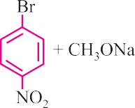
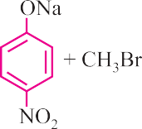
Q. 12. Which of the following is an appropriate set of reactants for the preparation of 1-methoxy-4-nitrobenzene and why ?

(i) (ii)

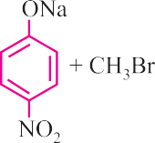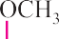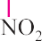Ans. (ii)

It is because of double bond character, (C – Br) bond in it is less reactive towards SN, RXN.

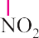due to resonance

Q. 13. Ethers are relatively inert. Justify.
Ans. Due to absence of any active site in their molecules, divalent oxygen is linked to carbon atoms on both sides ⎛C .. ⎞
− − C .
⎜
O ⎟
⎝ .. ⎠

Q. 14. How will you distinguish between CH3OH and C2H5OH ?

Ans. C2H5OH + 4I2
+ 3Na CO ⎯w⎯arm⎯→ CHI + HCOONa + 5NaI + 2H O + 3CO
Iodoform (yellow)
2 3 3 2 2

CH₃OH does not give this test.

SHORT ANSWER-II TYPE QUESTIONS (3 Marks)

Q. 1. Name the reagents which are used in the following conversions :
- 1º alcohol to an aldehyde

Butan-2-one to butan-2-ol
- Phenol to 2, 4, 6 tribromophenol

Ans. (i) PCC, a complex of chromium trioxide with pyridine and HCl.
178 | Chemistry-XII
- NaBH₄, sodium borohydride.
- Br₂ (water)

Q. 2. Write structures of the major products of the following :
- Mononitration of 3-methylphenol

Dinitration of 3-methylphenol
- Mononitration of phenyl ethanoate
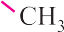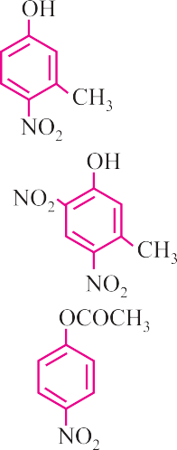Ans. – OH and – CH₃ are o- and p-directing groups. The products are :

(i)

(ii)

(iii)

Q. 3. Complete the following reactions :

- CH₃CH₂CH₂CHO
⎯P⎯d/ H⎯2 / N⎯i →

- CH3CH = CHCH2OH ⎯^{P}⎯^{CC}⎯→

CH CH = CH ⎯⎯⁽⎯¹⁾ ^{B}⎯2H⎯6 ⎯→

3 2 (2) 3H2O2/OH-
C H OH ⎯(⎯1) A⎯q.N⎯aO⎯H →

6 5 (2) CO2 ,H+
- CH Br – CH Br ⎯K⎯OH⎯→
2 2
- C H NH ⎯H⎯NO⎯2 →
2 5 2
Ans. (i) CH3CH2CH2CH2OH (ii) CH3CH = CHCH2 – OH
OH

(iii) CH3CH2CH2OH (iv)
COOH

- CH₂OH – CH₂OH
- CH₃CH₂OH

Q. 4. Give equations of the following reactions :
ALCOHOLS, PHENOLS AND ETHERS | 179
- Oxidation of propan-1-ol with alkaline KMnO₄ solution.

Bromine in CS₂ with phenol.
- Treating phenol with chloroform in presence of aqueous NaOH.

Ans. (i) CH
– CH – CH OH + 2[O]
⎯⎯alkal⎯ine → CH CH COO– K+

3 2 2
KMnO4 3 2

(ii)

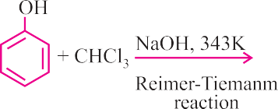
(iii)

Q. 5. Describe the following reactions with examples :
- Reimer-Teimann reaction

Kolbe’s reaction
- Friedel Crafts acylation of anisole

Ans. (i)

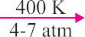(ii)
OH O– Na+
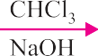
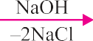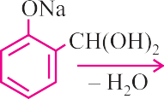CHCl2

(iii)

CH3COCl
anhy. AlCl₃

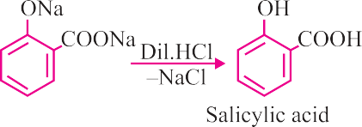
Cl

COCH3

Q. 6. Dehydration of alcohols to form an alkene is always carried out with conc. H2SO4 and not with conc. HCl or HNO3. Explain.
Ans. In acidic medium alcohols protonated then loses H₂O to form a carbo cation. If HCl Cl⁻ strong nucleophile cause nucleophilic substitution, HNO₃ causes oxidation.

Q. 7. How will you convert :
- Phenol to cyclohexanol

Benzyl chloride to benzyl alcohol

- Anisole to phenol
180 | Chemistry-XII
OH OH
2

Ans. (i)
+ H Ni

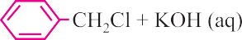(ii)

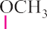(iii)

LONG ANSWER TYPE QUESTIONS (5 Marks)

Q. 1. An alcohol A (C4H10O) on oxidation with acidified K2Cr2O7 gives carboxylic acid ‘B’ (C4H8O2). Compound ‘A’ when dehydrated with conc. H2SO4 at 443 K gives compound ‘C’ with aqueous H₂SO₄. ‘C’ gives compound ‘D’ (C₄H₁₀O) which is an isomer of ‘A’. Compound ‘D’ is resistant to oxidation but compound ‘A’ can be easily oxidized. Identify A, B, C and D and write their structure.
Ans. A : (CH3)2CHCH2OH B : CH3CH(CH3)COOH C : (CH3)2C = CH2 D : (CH3)3 – C – OH

Q. 2. An ether ‘A’ (C₅H₁₂O) when heated with excess of hot concentrated HI produced two alkyl halides which on hydrolysis from compounds B and
C. Oxidation of B gives an acid D whereas oxidation of C gave a ketone E. Deduce the structures of A, B, C, D and E.
Ans. A : CH3CH2OCH B : CH3CH2OH
C : CH3CHOHCH3 D : CH3COOH E : CH₃COCH₃

Q. 3. Which of the following compounds gives fastest reaction with HBr and why?
(i) (CH3)3COH (ii) CH3CH2CH2OH

(iii) (iv)
Ans. (i) (CH₃)₃C – OH
Due to formation of EDG and formation of cation.

Q. 4. Phenol, C₆H₅OH when it first reacts with concentrated sulphuric acid,
forms Y. The compound, Y is reacted with concentrated nitric acid to form

Z. Identify Y and Z and explain why phenol is not converted commercially to Z by reacting it with conc. HNO₃.

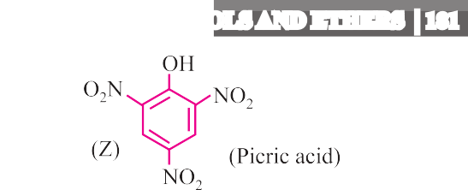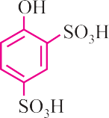For more FREE DOWNLOADS, visit www.aspirationsinstitute.com
ALCOHOLS, PHENOLS AND ETHERS | 181

Ans.

Phenol is not reacted directly with conc. HNO₃ because the yield of picric acid is very poor.

Q. 5. Fill in the blanks :
Zymase

Glucose
OH
2

+ Br2 HO ?

OH
COOH

(CH CO) O
3 2
H+ ?

CH3

- CH3CHOCH2CH3

HI ?

Phenol + Zn (dust) →
- Phenol + Na →

R2CHOH + HCl + ZnCl2 → R2CHCl + ..........
(anhydrous)

- R – CHOH – R ⎯[⎯O]→

OH Cl

|

CH₃ – CH – CH₃
⎯S⎯OC⎯l2→
|

CH₃ – CH – CH₃ +

- CH3
- CH2
- OH ⎯B⎯leac⎯hing⎯pow⎯der⎯→
Br

Ans. (i) C₂H₅OH (ii)
OCOCH3
COOH

Br Br
OH

(iii) (iv) (CH3)2CHOH and CH3CH2I

(v) C6H6 (vi) C6H5ONa O
||
(vii) H₂O (viii) R – C – R
(ix) SO₂ (x) CHCl₃

Source: EDUDEL

